**Project Work: Requirements Specifications.**

**Application under Test:** Sample Windows Flight Reservation Application

**Requirements and Test Cases to be maintained in ALM**.

Automate a test such that it contains 3 Actions - **Login**, **Reservation**, and **Logout**.

**Login** contains the script for logging in to the Flight Application.

**Reservation** contains the script for booking your flight. Reservation action also contains the script for sending a fax.

**Logout** contains the script for logging out of the application.

**Tasks:**

1. Make sure **Login** and **Logout** run only **once** whereas the **Reservation** runs multiple times.

2. Check that the Ok button of the login screen is enabled only when the Userid and password fields are populated.

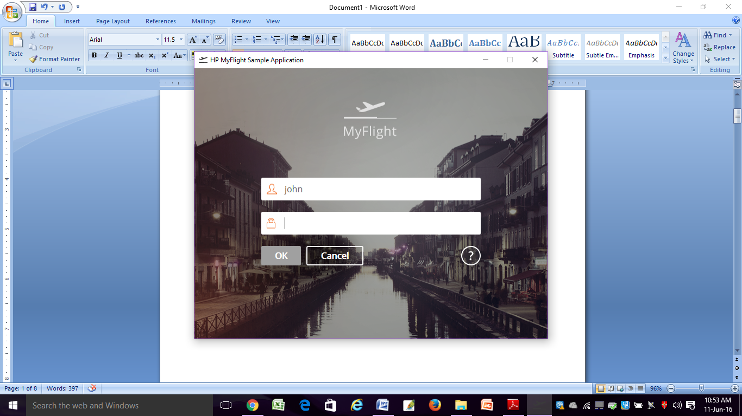

3. Select the origin (Fly From) and the destination (Fly To) cities randomly. Ensure that the script runs at least for 3 times.

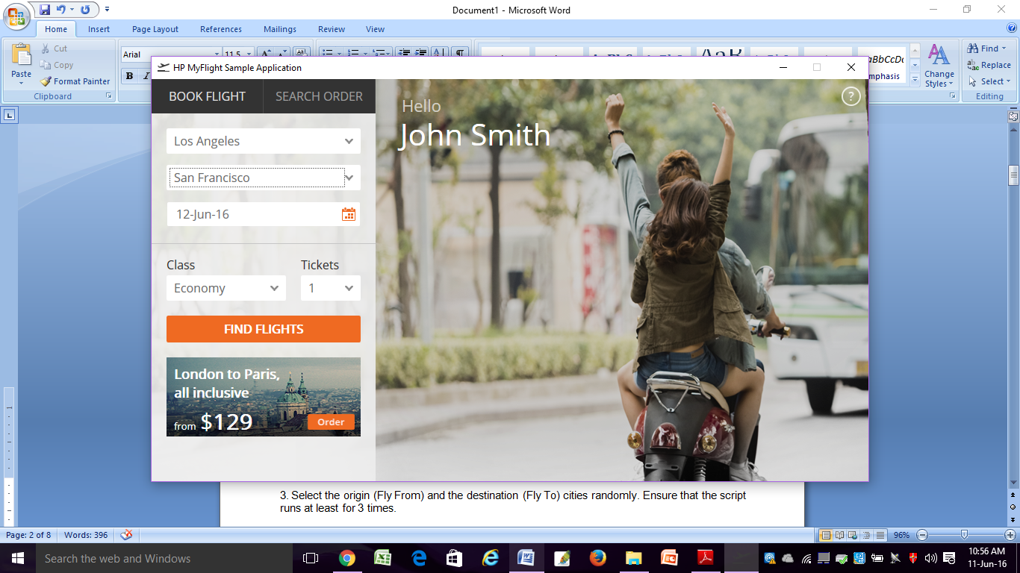

4. Ensure that the flight is chosen randomly from the list.

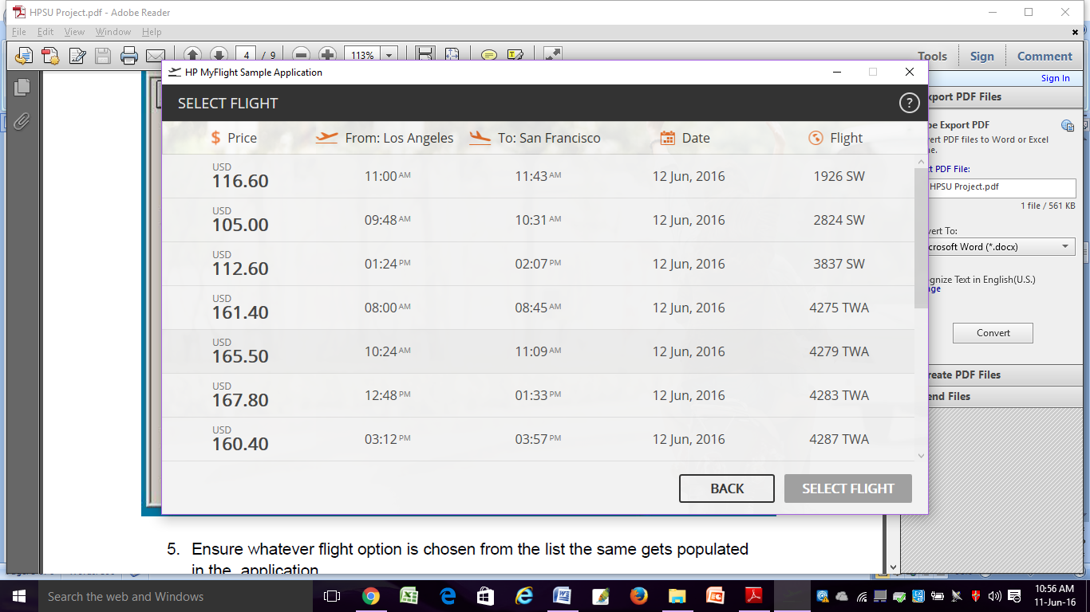

5. Ensure whatever flight option is chosen from the list the same gets populated in the application.

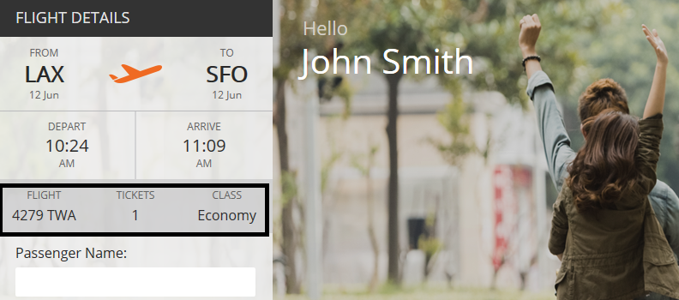

**Additional Checkpoints:**

6. Choose the number of tickets **randomly** and ensure that the number of tickets is less than 11.

7. Ask the user at run time for the class of travel using an **input box.** The user should enter **F/B/E** for indicating his class of travel either in First, Business or Economy class. Any other input from the user should give a message of invalid input and ask for his input again.

8. Based on the value input by the user to indicate his class of travel, the class of travel should be accordingly chosen at runtime.

9. Validate that the number of tickets multiplied by the Price of each ticket is equal to the Total.

10. Click on Order button to book the ticket and retrieve the order number from the displayed message.

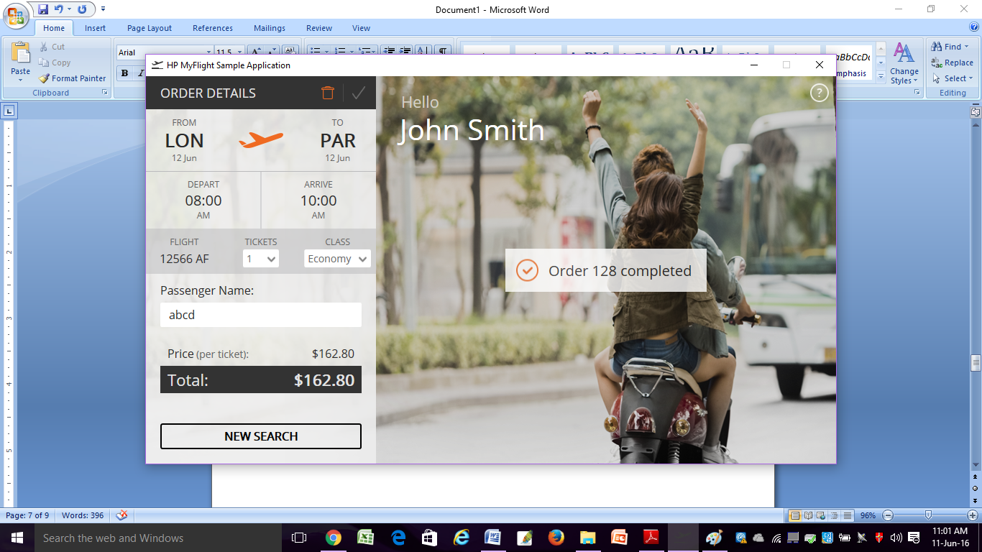

11. Make the form blank.